SMART ATTENDANCE SYSTEM WITH INSTANT PARENT CALL FEATTURE
Learning Block 1
Submitted by
ITHGANI RANJANI
Teegala Krishna Reddy Engineering College
Department of Computer Science and Engineering
Academic Year: Pre-Final– 2026–2027
GitHub link

Guided by: Raghavendra Rao

CONTENTS
TITLE | PAGE NO
1.Introduction | 1
2.Problem Statement | 1
3.Objectives | 1
4.Project Scope | 1
5.Proposed System/Methodology | 2-3
6.System Architecture/Workflow | 2-3
7.Implementation | 3-18
8.User Interface/Application Screenshots | 19-24
9.Challenges and Limitations | 25
10.Conclusion | 26
11.Future Scope | 26
12.References | 26

Introduction
The Smart Attendance System is a web-based solution designed to make attendance management faster, easier, and more accurate. Teachers can mark attendance online, while the data is securely stored in a centralized database. When a student is marked absent, parents receive instant SMS and call alerts, helping them stay informed about their child’s attendance. The system reduces manual work, saves time, improves transparency, and strengthens communication between teachers and parents.

Problem Statement
The proposed Smart Attendance System is a digital platform that simplifies attendance management through a web or mobile interface. Teachers can record attendance in real time, while all student and attendance data is securely stored in a centralized database. When a student is marked absent, the system automatically sends an SMS or call alert to the parent. It also calculates attendance percentages, identifies low attendance, generates reports, and allows students to view their attendance and marks. Overall, the system reduces manual work, saves time, minimizes errors, and improves communication between teachers, students, and parents.

Objectives
• To automate the attendance management process.
• To reduce manual work and save time.
• To maintain accurate attendance records.
• To calculate and monitor attendance percentage.
• To send instant SMS/call alerts to parents for student absence.
• To improve communication between teachers and parents.
• To provide a simple and user-friendly system.

Project Scope
The project focuses on developing a basic attendance management application for educational institutions.
The scope includes:
- Adding and managing student details.
- Recording daily attendance.
- Viewing attendance records.
- Calculating attendance percentages.
- To send instant SMS/call alerts to parents for student absence.
- Displaying the total number of students, present students, and absent students.
- Generating simple attendance reports.

The current version is designed as a browser-based prototype. It can be enhanced in the future to support multiple teachers, different classes, and centralized data storage.

Proposed System / Methodology
The Smart Attendance System uses automation to make attendance management faster and more effective.
- Teacher Login – Teacher securely logs into the system.
- Digital Attendance – Teacher marks students as Present/Absent online.
- Smart Absence Detection – The system automatically identifies absent students.
- Instant Parent Alert – An SMS/phone call is automatically sent to the parent.
- Automatic Calculation – The system calculates the attendance percentage.
- Low Attendance Detection – The system identifies students with low attendance.
- Student Access – Students can view their attendance and marks.
- Reports & Monitoring – Teachers can view and manage attendance reports.
The system is developed using HTML for the structure, CSS for the design, JavaScript for functionality, and browser local storage for saving data.

System Architecture / Workflow

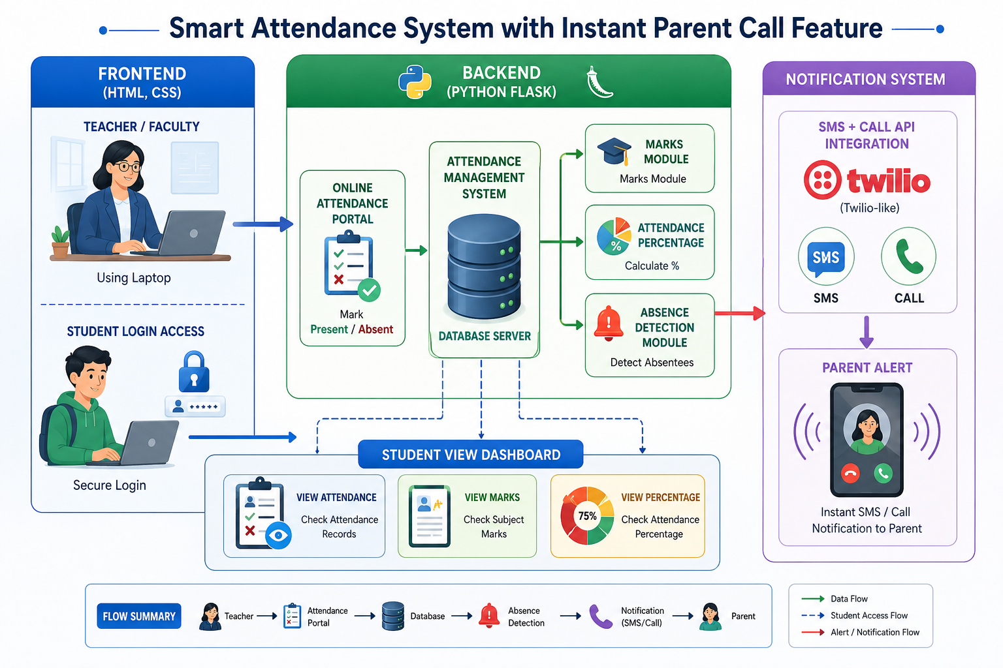

The system follows a simple three-part workflow involving the user interface, application logic, and browser storage.
- Start the application in a web browser.
- Add student details.
- Select the attendance date.
- Mark students as present or absent.
- Save the attendance records.
- View the dashboard and attendance reports.

Implementation
The project is implemented using three main files:
index.html: Defines the structure of the application, including the dashboard, student registration form, attendance table, and report section.
# ===== app.py =====
from flask import Flask, render_template, request, redirect, session
import sqlite3
from datetime import datetime
app = Flask(__name__)
app.secret_key = "secret123"
# ================= DATABASE =================
def get_db():
conn = sqlite3.connect("smart_attendance.db")
conn.row_factory = sqlite3.Row
return conn
# ================= SEND DEMO NOTIFICATIONS =================
def send_notification(student_name, parent_phone):
"""Send demo notification about student absence"""
if not parent_phone or parent_phone.strip() == "":
return f"⚠️ {student_name}: No phone number on file"
# Demo SMS notification
sms_msg = f"📱 SMS sent to {parent_phone}: 'Alert: Today {student_name} is absent. Please contact school immediately.'"
print(sms_msg)
# Demo Call notification
call_msg = f"📞 CALL made to {parent_phone}: 'Automated message: {student_name} is absent today. Please contact school.'"
print(call_msg)
return f"✅ {student_name} - SMS & Call notification sent"
# ================= LOGIN =================
@app.route('/', methods=['GET','POST'])
def login():
if request.method == 'POST':
db = get_db()
user = db.execute(
"SELECT * FROM users WHERE username=? AND password=?",
(request.form['username'], request.form['password'])
).fetchone()
if user:
session['user'] = user['username']
session['role'] = user['role']
session['student_id'] = user['student_id']
return redirect('/dashboard')
return render_template("login.html")
# ================= DASHBOARD =================
@app.route('/dashboard')
def dashboard():
if 'user' not in session:
return redirect('/')
return render_template("dashboard.html", role=session['role'])
# ================= TAKE ATTENDANCE =================
@app.route('/attendance', methods=['GET','POST'])
def attendance():
if session.get('role') != 'teacher':
return redirect('/')
db = get_db()
if request.method == 'POST':
students = db.execute("SELECT * FROM students").fetchall()
messages = []
date = datetime.now().strftime('%Y-%m-%d')
for s in students:
status = request.form.get(f"status_{s['id']}")
if status:
db.execute(
"INSERT INTO attendance (student_id, status, date) VALUES (?,?,?)",
(s['id'], status, date)
)
# Send notification for absent students
if status == "Absent":
result = send_notification(s['name'], s['parent_phone'])
messages.append(result)
db.commit()
return render_template("success.html", messages=messages)
students = db.execute("SELECT * FROM students").fetchall()
return render_template("attendance.html", students=students)
# ================= EDIT ATTENDANCE =================
@app.route('/edit_attendance', methods=['GET','POST'])
def edit_attendance():
if session.get('role') != 'teacher':
return redirect('/')
db = get_db()
if request.method == 'POST’:
db.execute(
"UPDATE attendance SET status=? WHERE id=?",
(request.form['status'], request.form['attendance_id’])
)
db.commit()
return redirect('/edit_attendance')
records = db.execute("""
SELECT attendance.id, students.name, attendance.status, attendance.date
FROM attendance
JOIN students ON students.id = attendance.student_id ORDER BY attendance.date DESC
""").fetchall()
return render_template("edit_attendance.html", records=records)
# ================= VIEW ATTENDANCE =================
@app.route('/view_attendance')
def view_attendance():
if 'user' not in session:
return redirect('/')
db = get_db()
if session['role'] == 'student':
records = db.execute("""
SELECT students.name, attendance.status, attendance.date
FROM attendance
JOIN students ON students.id = attendance.student_id
WHERE students.id=?
ORDER BY attendance.date DESC
""", (session['student_id'],)).fetchall()
else:
records = db.execute("""
SELECT students.name, attendance.status, attendance.date
FROM attendance
JOIN students ON students.id = attendance.student_id
ORDER BY attendance.date DESC
""").fetchall()
return render_template("view_attendance.html", records=records)
# ================= MARKS =================
@app.route('/marks', methods=['GET','POST'])
def marks():
if session.get('role') != 'teacher':
return redirect('/')
db = get_db()
if request.method == 'POST':
subject = request.form['subject']
students = db.execute("SELECT * FROM students").fetchall()
date = datetime.now().strftime('%Y-%m-%d')
messages = []
# Insert marks for all students
for s in students:
marks_value = request.form.get(f"marks_{s['id']}")
if marks_value and marks_value.strip() != "":
db.execute(
"INSERT INTO marks(student_id, subject, marks, date) VALUES (?,?,?,?)",
(s['id'], subject, marks_value, date)
)
messages.append(f"✅ {s['name']} - {marks_value}/100")
db.commit() return render_template("success.html", messages=messages)
students = db.execute("SELECT * FROM students").fetchall()
return render_template("marks.html", students=students)
# ================= VIEW MARKS =================
@app.route('/view_marks', methods=['GET','POST'])
def view_marks():
if 'user' not in session:
return redirect('/')
db = get_db()
selected_subject = request.args.get('subject', '')
records = []
subjects = []
# Get all unique subjects
if session['role'] == 'student':
subject_query = db.execute("""
SELECT DISTINCT marks.subject
FROM marks
JOIN students ON students.id = marks.student_id
WHERE students.id=?
ORDER BY marks.subject
""", (session['student_id'],)).fetchall()
else:
subject_query = db.execute("""
SELECT DISTINCT marks.subject
FROM marks
ORDER BY marks.subject
""").fetchall()
subjects = [row['subject'] for row in subject_query]
# Get records for selected subject
if selected_subject:
if session['role'] == 'student':
records = db.execute(""“
SELECT students.name, marks.subject, marks.marks, marks.date
FROM marks
JOIN students ON students.id = marks.student_id
WHERE students.id=? AND marks.subject=?
ORDER BY marks.date DESC
""", (session['student_id'], selected_subject)).fetchall()
else:
records = db.execute("""
SELECT students.name, marks.subject, marks.marks, marks.date
FROM marks
JOIN students ON students
WHERE marks.subject=?
ORDER BY marks.date DESC
""", (selected_subject,)).fetchall()
return render_template("view_marks.html", records=records, subjects=subjects, selected_subject=selected_subject) # ================= PERCENTAGE =================
@app.route('/percentage')
def percentage():
if 'user' not in session:
return redirect('/')
db = get_db()
data = db.execute("""
SELECT students.name,
SUM(CASE WHEN attendance.status='Present' THEN 1 ELSE 0 END) as present,
COUNT(attendance.id) as total
FROM attendance
JOIN students ON students.id = attendance.student_id
GROUP BY students.id
""").fetchall()
result = []
for r in data:
percent = (r['present']/r['total'])*100 if r['total'] > 0 else 0
warning = "⚠ Low Attendance" if percent < 65 else "OK"
result.append((r['name'], r['present'], r['total'], round(percent,2), warning))
return render_template("percentage.html", data=result)
# ================= REPORT =================
@app.route('/report')
def report():
if 'user' not in session:
return redirect('/')
db = get_db()
records = db.execute("""
SELECT students.name, attendance.status, attendance.date
FROM attendance
JOIN students ON students.id = attendance.student_id
""").fetchall()
return render_template("report.html", records=records)
# ================= LOGOUT =================
@app.route('/logout')
def logout():
session.clear()
return redirect('/')
# ================= RUN =================
if __name__ == '__main__':
app.run(debug=True)
# ===== templates/login.html =====
<!DOCTYPE html>
<html lang="en">
<head>
<meta charset="UTF-8">
<title>Smart Attendance Login</title> <style>
* {
margin: 0;
padding: 0;
box-sizing: border-box;
font-family: Arial, sans-serif;
}
body {
height: 100vh;
background: url('https://www.targetadmission.com/img/colleges/newc/10224-101693.png') no-repeat center center/cover;
background-attachment: fixed;
display: flex;
justify-content: center;
align-items: center;
}
/* Dark overlay */
body::before {
content: "";
position: absolute;
width: 100%;
height: 100%;
background: rgba(0, 0, 0, 0.5);
top: 0;
left: 0;
}
.login-container {
position: relative;
background: rgba(255, 255, 255, 0.95);
padding: 40px;
border-radius: 12px;
width: 340px;
box-shadow: 0 8px 25px rgba(0,0,0,0.3);
text-align: center;
z-index: 1;
}
.college-logo {
font-size: 20px;
font-weight: bold;
color: #007BFF;
margin-bottom: 5px;
}
.title {
font-size: 22px;
font-weight: bold;
margin-bottom: 5px;
} .subtitle {
font-size: 14px;
margin-bottom: 20px;
color: #555;
}
input {
width: 100%;
padding: 10px;
margin: 10px 0;
border-radius: 6px;
border: 1px solid #ccc;
}
input:focus {
border-color: #007BFF;
outline: none;
}
button {
width: 100%;
padding: 10px;
margin-top: 10px;
background: #007BFF;
color: white;
border: none;
border-radius: 6px;
cursor: pointer;
font-size: 16px;
}
button:hover {
background: #0056b3;
}
</style>
</head>
<body>
<div class="login-container">
<!-- College Logo Text -->
<div class="college-logo">TKR ENGINEERING COLLEGE</div>
<div class="title">Smart Attendance</div>
<div class="subtitle">Login Portal</div>
<form method="POST">
<input type="text" name="username" placeholder="Username" required>
<input type="password" name="password" placeholder="Password" required>
<button type="submit">Login</button>
</form>
</div>
</body>
</html># ===== templates/dashboard.html =====
<!DOCTYPE html>
<html lang="en">
<head>
<meta charset="UTF-8">
<title>Dashboard</title>
<link rel="stylesheet" href="https://cdnjs.cloudflare.com/ajax/libs/font-awesome/6.5.0/css/all.min.css">
<style>
* {
margin: 0;
padding: 0;
box-sizing: border-box;
font-family: Arial, sans-serif;
}
body {
height: 100vh;
background: url('https://www.targetadmission.com/img/colleges/newc/10224-101693.png') no-repeat center center/cover;
display: flex;
justify-content: center;
align-items: center;
}
body::before {
content: "";
position: absolute;
width: 100%;
height: 100%;
background: rgba(0,0,0,0.6);
}
.dashboard-container {
position: relative;
width: 420px;
padding: 30px;
background: rgba(255,255,255,0.95);
border-radius: 15px;
box-shadow: 0 10px 30px rgba(0,0,0,0.4);
z-index: 1;
}
.college-title {
text-align: center;
font-size: 18px;
font-weight: bold; color: #007BFF;
margin-bottom: 10px;
}
h1 {
text-align: center;
margin-bottom: 20px;
}
.menu {
display: flex;
flex-direction: column;
gap: 12px;
}
.menu a {
display: flex;
align-items: center;
text-decoration: none;
padding: 12px;
border-radius: 8px;
background: #007BFF;
color: white;
font-weight: bold;
transition: 0.3s;
}
.menu a:hover {
background: #0056b3;
transform: scale(1.04);
}
.logout {
background: #dc3545 !important;
}
.logout:hover {
background: #a71d2a !important;
}
</style>
</head>
<body>
<div class="dashboard-container">
<div class="college-title">TKR ENGINEERING COLLEGE</div>
<div class="menu">
<!-- 👨‍🏫 TEACHER MENU -->
{% if role == 'teacher’ %}
<h1><i class="fa-solid fa-gauge"></i>Teacher Dashboard</h1>
<a href="/attendance"><i class="fa-solid fa-user-check"></i> Take Attendance</a>
<a href="/edit_attendance"><i class="fa-solid fa-pen-to-square"></i> Edit Attendance</a>
<a href="/marks"><i class="fa-solid fa-file-pen"></i> Enter Marks</a><a href="/view_attendance"><i class="fa-solid fa-eye"></i> View Attendance</a>
<a href="/view_marks"><i class="fa-solid fa-chart-column"></i> View Marks</a>
<a href="/percentage"><i class="fa-solid fa-percent"></i> Attendance %</a>
{% else %}
<!-- 🎓 STUDENT MENU -->
<h1><i class="fa-solid fa-gauge"></i>Student Dashboard</h1>
<a href="/view_attendance"><i class="fa-solid fa-eye"></i> View Attendance</a>
<a href="/view_marks"><i class="fa-solid fa-chart-column"></i> View Marks</a>
<a href="/percentage"><i class="fa-solid fa-percent"></i> Attendance %</a>
{% endif %}
<a href="/logout" class="logout">
<i class="fa-solid fa-right-from-bracket"></i> Logout
</a>
</div>
</div>
</body>
</html>
# ===== templates/attendance.html =====
<!DOCTYPE html>
<html lang="en">
<head>
<meta charset="UTF-8">
<meta name="viewport" content="width=device-width, initial-scale=1.0">
<title>Take Attendance</title>
<link rel="stylesheet" href="{{ url_for('static', filename='style.css') }}">
<style>
* {
margin: 0;
padding: 0;
box-sizing: border-box;
}
body {
font-family: 'Segoe UI', Tahoma, Geneva, Verdana, sans-serif;
background: url('https://www.targetadmission.com/img/colleges/newc/10224-101693.png') no-repeat center center/cover;
background-attachment: fixed;
min-height: 100vh;
display: flex;
align-items: center;
justify-content: center;
padding: 20px;
position: relative;
}
/* Dark overlay */
body::before {
content: ""; position: absolute;
width: 100%;
height: 100%;
background: rgba(0, 0, 0, 0.5);
top: 0;
left: 0;
z-index: 0;
}
.container {
background: rgba(255, 255, 255, 0.95);
border-radius: 12px;
box-shadow: 0 20px 60px rgba(0, 0, 0, 0.3);
padding: 40px;
max-width: 600px;
width: 100%;
position: relative;
z-index: 1;
}
h2 {
color: #333;
margin-bottom: 30px;
font-size: 28px;
text-align: center;
}
form {
display: flex;
flex-direction: column;
gap: 20px;
}
.student-card {
display: flex;
align-items: center;
justify-content: space-between;
padding: 15px;
background: #f8f9fa;
border-radius: 8px;
border-left: 4px solid #007BFF;
transition: all 0.3s ease;
}
.student-card:hover {
background: #f0f1f5;
box-shadow: 0 4px 12px rgba(0, 123, 255, 0.15);
}
.student-name {
font-weight: 600;
color: #333;
font-size: 16px; flex: 1;
}
.radio-group {
display: flex;
gap: 15px;
}
.radio-wrapper {
display: flex;
align-items: center;
gap: 6px;
}
input[type="radio"] {
width: 18px;
height: 18px;
cursor: pointer;
accent-color: #007BFF;
}
.radio-wrapper label {
cursor: pointer;
font-weight: 500;
color: #555;
font-size: 14px;
}
.button-group {
display: flex;
gap: 10px;
margin-top: 10px;
}
button {
flex: 1;
padding: 12px 24px;
font-size: 16px;
font-weight: 600;
border: none;
border-radius: 8px;
cursor: pointer;
transition: all 0.3s ease;
}
.btn-submit {
background: #007BFF;
color: white;
}
}
.btn-submit:hover {
background: #0056b3;
transform: translateY(-2px);
box-shadow: 0 10px 20px rgba(0, 123, 255, 0.3);
}
.btn-back {
background: #e9ecef; color: #333;
}
.btn-back:hover {
background: #dee2e6;
}
.alert {
padding: 12px;
border-radius: 8px;
margin-bottom: 20px;
text-align: center;
}
.alert-info {
background: #e7f3ff;
color: #004085;
border: 1px solid #b3d9ff;
}
</style>
</head>
<body>
<div class="container">
<h2>📋 Take Attendance</h2>
<div class="alert alert-info">
Select Present or Absent for each student
</div>
<form method="post">
{% for student in students %}
<div class="student-card">
<span class="student-name">{{ student['name'] }}</span>
<div class="radio-group">
<div class="radio-wrapper">
<input type="radio" id="present_{{ student['id'] }}" name="status_{{ student['id'] }}" value="Present" required>
<label for="present_{{ student['id'] }}">✓ Present</label>
</div>
<div class="radio-wrapper">
<input type="radio" id="absent_{{ student['id'] }}" name="status_{{ student['id'] }}" value="Absent">
<label for="absent_{{ student['id'] }}">✗ Absent</label>
</div>
</div>
</div>
{% endfor %}
<div class="button-group">
<button type="submit" class="btn-submit">✓ Submit Attendance</button>
<button type="button" class="btn-back" onclick="window.history.back()">← Back</button> </div>
</form>
</div>
</body>
</html>
# ===== templates/marks.html =====
<!DOCTYPE html>
<html lang="en">
<head>
<meta charset="UTF-8">
<meta name="viewport" content="width=device-width, initial-scale=1.0">
<title>Enter Marks</title>
<style>
* {
margin: 0;
padding: 0;
box-sizing: border-box;
}
body {
font-family: 'Segoe UI', Tahoma, Geneva, Verdana, sans-serif;
background: url('https://www.targetadmission.com/img/colleges/newc/10224-101693.png') no-repeat center center/cover;
background-attachment: fixed;
min-height: 100vh;
display: flex;
align-items: center;
justify-content: center;
padding: 20px;
position: relative;
}
/* Dark overlay */
body::before {
content: "";
position: absolute;
width: 100%;
height: 100%;
background: rgba(0, 0, 0, 0.5);
top: 0;
left: 0;
z-index: 0;
}
.container {
background: rgba(255, 255, 255, 0.95);
border-radius: 12px;
box-shadow: 0 20px 60px rgba(0, 0, 0, 0.3);
padding: 40px;
max-width: 500px; width: 100%;
position: relative;
z-index: 1;
}
h2 {
color: #333;
margin-bottom: 30px;
font-size: 28px;
text-align: center;
}
form {
display: flex;
flex-direction: column;
gap: 20px;
}
.form-group {
display: flex;
flex-direction: column;
}
label {
font-weight: 600;
color: #333;
margin-bottom: 8px;
font-size: 14px;
text-transform: uppercase;
}
select,
input[type="text"],
input[type="number"] {
padding: 12px;
border: 2px solid #ddd;
border-radius: 8px;
font-size: 16px;
font-family: 'Segoe UI', Tahoma, Geneva, Verdana, sans-serif;
transition: all 0.3s ease;
}
select:focus,
input[type="text"]:focus,
input[type="number"]:focus {
outline: none;
border-color: #007BFF;
box-shadow: 0 0 0 3px rgba(0, 123, 255, 0.1);
}
select:hover,
input[type="text"]:hover,
input[type="number"]:hover {
border-color: #007BFF;
}
select {
cursor: pointer;
background: white;
appearance: none;
background-image: url("data:image/svg+xml;charset=UTF-8,%3csvg xmlns='http://www.w3.org/2000/svg' viewBox='0 0 24 24' fill='none' stroke='currentColor' stroke-width='2' stroke-linecap='round' stroke-linejoin='round'%3e%3cpolyline points='6 9 12 15 18 9'%3e%3c/polyline%3e%3c/svg%3e");
background-repeat: no-repeat;
background-position: right 10px center;
background-size: 20px;
padding-right: 40px;
}
.form-group:last-of-type {
margin-bottom: 10px;
}
button {
padding: 12px 24px;
font-size: 16px;
font-weight: 600;
border: none;
border-radius: 8px;
cursor: pointer;
transition: all 0.3s ease;
background: linear-gradient(135deg, #007BFF 0%, #0056b3 100%);
color: white;
margin-top: 10px;
}
button:hover {
transform: translateY(-2px);
box-shadow: 0 10px 20px rgba(0, 123, 255, 0.3);
}
button:active {
transform: translateY(0);
}
.back-link {
display: inline-block;
margin-top: 20px;
text-align: center;
padding: 10px;
color: #007BFF;
text-decoration: none;
font-weight: 600;
transition: all 0.3s ease;
}
.back-link:hover {
color: #0056b3;
}
@media (max-width: 600px) {
.container {
padding: 30px 20px;
}
h2 {
font-size: 24px;
}
.student-row {
grid-template-columns: 1fr;
}
}
.students-table {
width: 100%;
margin-top: 20px;
}
.student-row {
display: grid;
grid-template-columns: 2fr 1fr;
gap: 12px;
margin-bottom: 12px;
padding: 12px;
background: #f8f9fa;
border-radius: 8px;
align-items: center;
}
.student-name {
font-weight: 500;
color: #333;
}

User Interface / Application Screenshots
The application contains the following main screens.

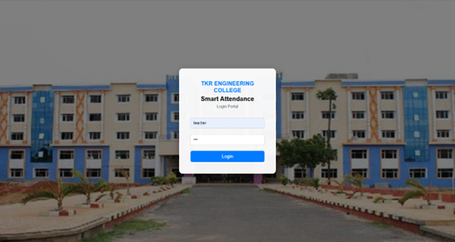

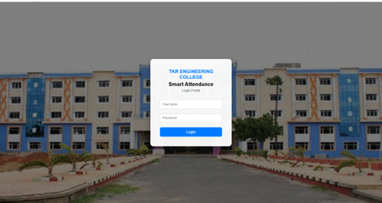

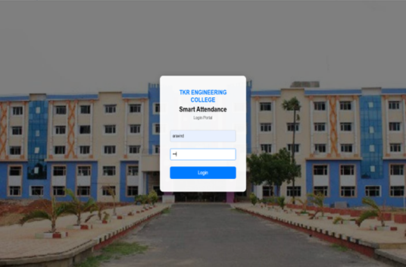

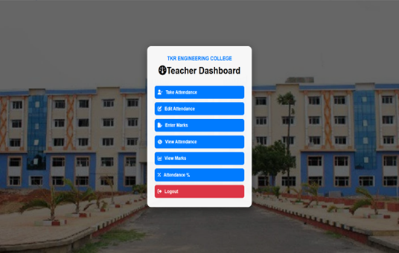

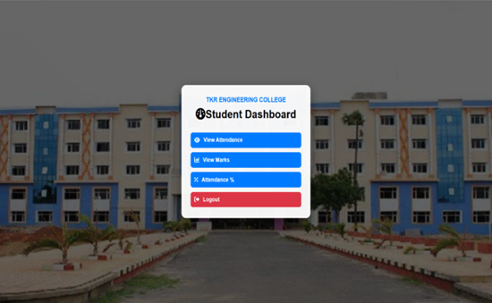

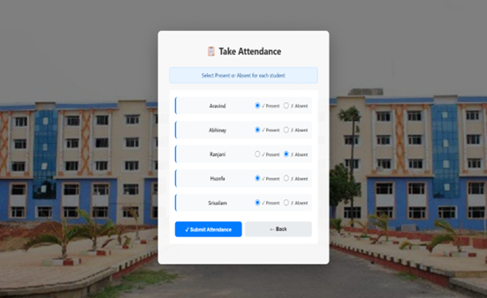

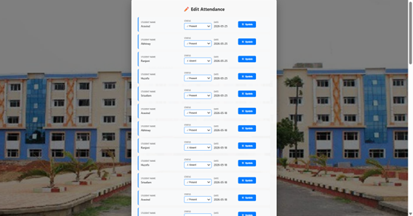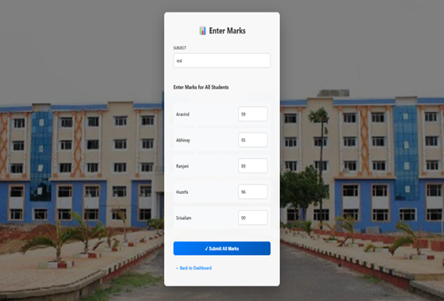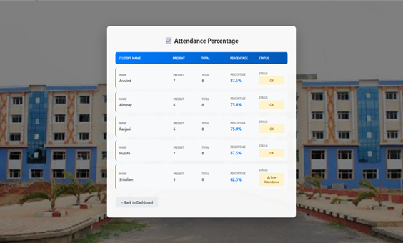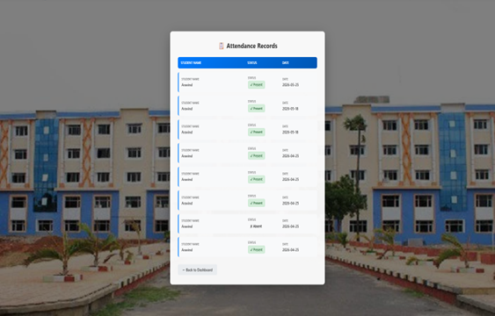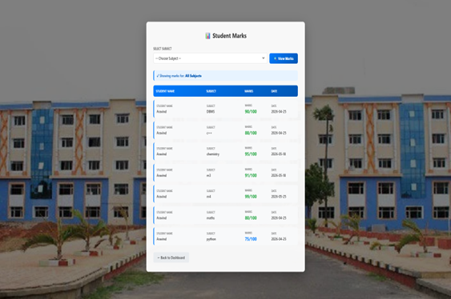

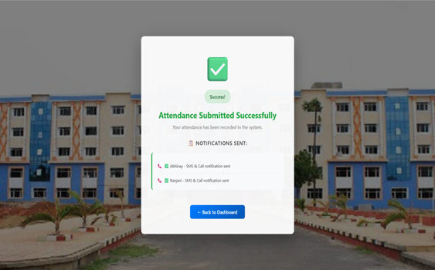

Displays the list of students with options to mark attendance as present or absent for a selected date.

Displays each student's roll number, name, present days, total attendance days, and attendance percentage.

9. Challenges and Limitations

Challenges
- Setting up a reliable SMS and call notification system.
- Maintaining accurate student and parent information.
- Ensuring database security and data privacy.
- Handling internet/network issues.
- Managing attendance for a large number of students.
- Preventing incorrect attendance entries.
- Saving and retrieving attendance data using local storage.

Limitations

- Requires a stable internet connection.
- SMS and calls may require a paid service such as Twilio.
- Parent phone numbers must be correct and active.
- The system depends on the availability of the notification service.
- It requires proper login and data security.
- The current system is mainly designed for web-based attendance management.

10.Conclusion

The Smart Attendance System with Instant Parent Call Feature provides a simple, fast, and efficient way to manage student attendance. It reduces manual work, saves time, improves accuracy, and automatically calculates attendance. The system also sends SMS/call alerts to parents when a student is absent, improving communication and student monitoring. Overall, it is a user-friendly and reliable solution for educational institutions.

11.Future Scope
The project can be improved with additional features in the future:
- Login and Authentication: Add secure login facilities for teachers and administrators.
- Database Integration: Use a centralized database to store and manage student records.
- SAP Integration: Connect the application to a suitable SAP platform if required by the training program.
- Automated Notifications: Send alerts to students when their attendance falls below a specified percentage.
- Export Reports: Allow users to download attendance reports in PDF or Excel format.
- Multiple Classes: Support attendance management for different classes and departments.
- Mobile Compatibility: Improve the application for convenient use on smartphones and tablets.

12. References

- MDN Web Docs. “Web Storage API.” Available at: https://developer.mozilla.org/en-US/docs/Web/API/Web_Storage_API
- Visual Studio Code Documentation. “Getting Started.” Available at: https://code.visualstudio.com/docs
- GeeksforGeeks. “Student Attendance Management System.” Available at: https://www.geeksforgeeks.org/
- Google AI for Developers. “Generative AI.” Available at: https://ai.google.dev/
- SAP. “SAP Learning.” Available at: https://learning.sap.com/

